IP65 DOWNLIGHTS
ITEM NO: VT-7035; WATTS:35W
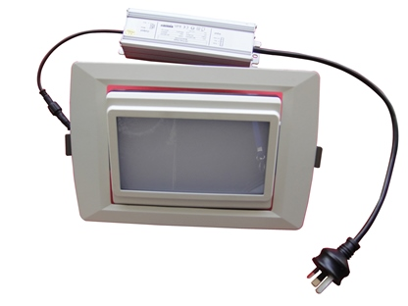
Item No: | VT-7035
Shape | Rectangle
Real Watts | 35W
Voltage | 85~265V
Input Frequency | 50/60Hz
Input Efficiency | 60lm/W
Lumen(lm) | 2100lm
PF | >0.9
CRI | >70
Color Temperature | 3000K,4500K,6000K
Beam Angle | 160’D
LED Type | SMD
Body Material | Powder Coating Aluminum
Color of Fixture | PKW
Dimmable | No
Protection Class | IP65
Unit size | 170mm*264mm*64mm
Cutting Size | 225mm*150mm
Life Time | 20000hrs
Operation Temperature | -25 ~50’C
Applicable Environment | Indoor Lighting, Used in Home down light, Stairwell lighting.

