COB DOWNLIGHT
ITEM NO: VT-2646; WATTS:40W
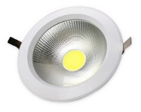
Item No: | VT-2646
SKU Code | 1220:3000K
Real Watts | 40W
EQ. Watts | 100W
Voltage | 100~240V
Input Frequency | 50/60Hz
Input Current | 130ma
Input Efficiency | 70lm/w
Lumen(lm) | 3200lm
PF | >0.9
RA | >70
Color Temperature | 3000K,4500K,6000K
Beam Angle | 120’D
LED Chip | Taiwan chip
LED Type | COB
Driver | Constant current power supply
Protection Class | IP20
Body Material | Aluminum + Plastic Cover
Dimmable | No
Unit size | D:221x103mm
Cutting Size | D:207mm
Life Time | 20000hrs
Operation Temperature | -25 ~50’C
Applicable Environment | Indoor Lighting, Used in Home down light, Stairwell lighting.

