COB DOWNLIGHT
ITEM NO: VT-2635;WATTS:30W
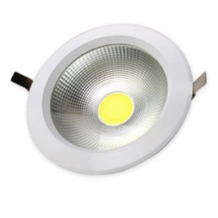
Item No: | VT-2635
SKU Code | 1217:3000K
Real Watts | 30W
EQ. Watts | 75W
Voltage | 100~240V
Input Frequency | 50/60Hz
Input Current | 130ma
Input Efficiency | 70lm/w
Lumen(lm) | 2400lm
PF | >0.9
RA | >70
Color Temperature | 3000K,4500K,6000K
Beam Angle | 120’D
LED Chip | Taiwan chip
LED Type | COB
LED Qty | 1
Driver | Constant current power supply
Protection Class | IP20
Body Material | Aluminum + Plastic Cover
Dimmable | No
Unit size | Φ181mm*83mm
Cutting Size | Φ167mm
Life Time | 20000hrs
Operation Temperature | -25 ~50’C
Applicable Environment | Indoor Lighting, Used in Home down light, Stairwell lighting.

